ACTIVA is a software that automatically adjusts the infusions of propofol and remifentanil during surgical procedures based on the patient’s depth of hypnosis. Its main logical structure is reported in the following scheme:

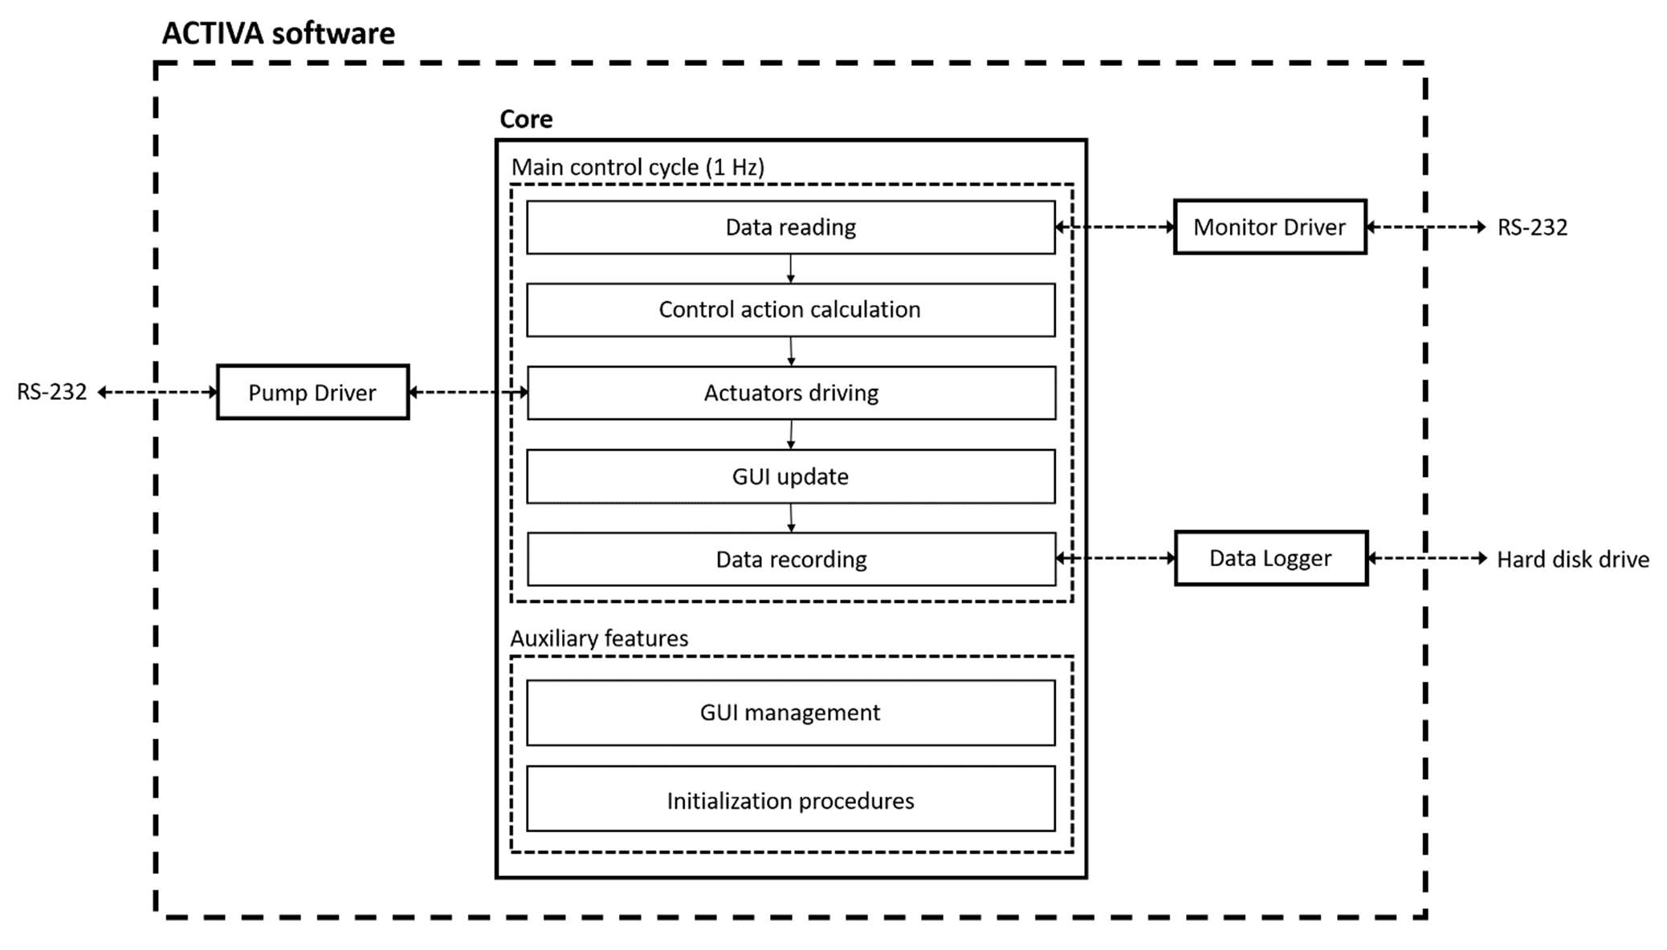
Where the main components are:
- Core: it is the main part of the ACTIVA software, it manages the communication with external devices, GUI (Graphical User Interface), data recording and control action calculation. It is divided into two main subparts:
  - Main control cycle: it is a cyclic task which is executed at the frequency of 1 Hz (in order to deal with the external monitor calculation time) and it is composed by the following steps:
    - Data reading: data acquisition from monitor;
    - Control action calculation: the control action is calculated according to a control algorithm;
    - Actuators driving: the infusion pumps are commanded according to the computed control action;
    - GUI update: the GUI is updated in order to provide a visual feedback to the anesthesiologist;
    - Data recording: the data regarding patient’s vital signs and pumps’ infusions are recorded.
  - Auxiliary features: contains the asynchronous routines for the initial handshakes with the external devices and it contains the interactive GUI management.
- Monitor Driver: it is a software module specifically written in order to manage the communication with the monitor;
- Pump Driver: it is a software module specifically written in order to manage the communication with the infusion pumps;
- Data Logger: manages the data saving on the hard disk drive.

The ACTIVA software is currently written in MATLAB language by following the Object-Oriented programming paradigm. Hence, the Monitor Driver and Pump Driver, which are the only hardware-dependent parts of the software, are two classes.
Currently the software is acquiring data from a Dräger Delta XL monitor.
The acquired data are:
    - Bispectral Index Scale [BIS]
    - Signal Quality Index [SQI]
    - Burst Suppression Ratio [BSR]
    - Spectral Edge Frequency [SEF]
    - Power Spectrum [POW]
    - Forehead EMG [EMG]
    - Heart Rate [HR]
    - Pulse Rate [PR]
    - Oxygen saturation [OS]
    - Systolic Pressure (noninvasive) [BP_s]
    - Diastolic Pressure (noninvasive) [BP_d]
    - Mean Pressure (noninvasive) [BP_m]
These data are acquired at the maximum frequency allowed by the Dräger Delta XL which is 1 Hz.

